Chapter 4, Problem 16.

Given the circuit in Fig. 4.84, use superposition to obtain i_{o}.

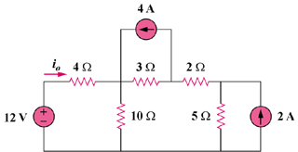

Figure 4.84
For Prob. 4.16

